Principles for Object-Oriented Software Design

Basic Principles for Class Design
The principles of object-oriented design are guidelines for designing software that is flexible, reusable, and able to accommodate changing requirements. Several software developers have identified principles and patterns (which are strategies for achieving the principles). Robert Martin identified five of the most important principles for class design, known as the SOLID Principles, namely:

SRP | Single Responsibility Principle | A class should have only one reason to change.
OCP | Open Closed Principle | A class should be open for extension but closed for modification. You should be able to extend a class's behavior without modifying it.
LSP | Liskov Substitution Principle | Derived classes must be substitutable for their base classes.
ISP | Interface Segregation Principle | Make fine grained interfaces that are client specific.
DIP | Dependency Inversion Principle | Depend on abstractions, not on concretions.

Single Responsibility Principle
A class should have only one reason to change
All the class's methods should be related to that purpose. A Purse is responsible for managing objects in the Purse, not for printing the contents or saving them to a file. A Coin is responsible for the value of Coin. This is related to high cohesion.
Combining multiple, unrelated responsibilities into a single class makes it less flexible and harder to modify or reuse.

Open-Closed Principle
Classes (or modules) should be open for extension,
but closed for modification.
We should be able to modify the behavior the behavior of a software entity without modifying the source code. But be reasonable -- don't overdesign for things that are not likely to happen.
How to do it? "The key is abstraction", writes Robert Martin.
Consider drawing shapes on a Canvas in the lab on Graphics 2D. The Canvas (drawing area) doesn't depend on a particular shape, like a Ball. Instead we define an interface for drawable shapes (an abstraction). The Canvas depends only on this interface, so we can use it to draw any object that implements the interface.
The AWT and Swing graphics do this, too. Containers draw Components. Component is an abstract class. You can add new Components as subclasses of Component. You can even change how an existing component works by subclassing it and overriding some methods, like paint and repaint.
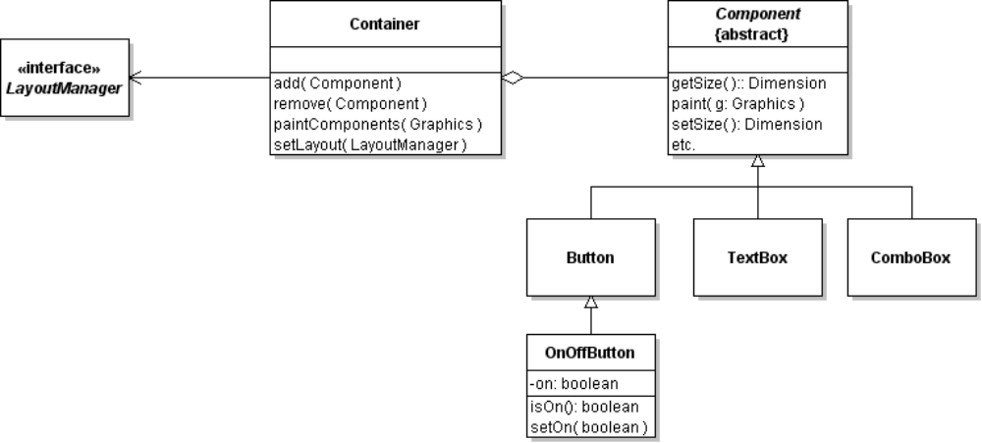
1. Attributes should be private. This prevents unauthorized access (class is closed).
2. The behavior that should be open for modification or extension should be defined as an interface or abstract class.
3. For behavior that should not be modified, declare the method as final. Some methods are used by other methods to fulfill their "contract". If a subclass overrides these, it may violate the contract.
A strategy for achieving OCP is "separate what varies from that which stays the same".
Consider the Container in AWT graphics. A Container is responsible for containing a collection of components. How the components are laid out can change -- clearly different applications will want different layouts of components. AWT handles it by separating the responsibility of arranging and sizing components from the responsibility of managing and painting components (SRP).

Liskov Substitution Principle
The LSP is a guideline to when inheritance is valid. OO languages let us use a subclass object anyplace where the application is expecting an object of the parent type, and the application should still work correctly.
To check the LSP, look at the behavior (methods) of a class and their "contracts":
- the preconditions for using a subclass method should be no stronger than preconditions of the parent class method,
- the postcondtions (what is true after a method is called) of subclass method should be at least as strong as the parent class method.
Consider a Stack. A stack has push(), pop(), and peak() methods. After we call push(object) the Stack should contain one more object than before. If the Stack is full, push(object) throws an exception.
Managing a stack is a nuisance because it can overflow. So we write a LeakyStack subclass that looks like a Stack, but is never full. If LeakyStack runs out of space, it just discards the element at the bottom of the stack. Logically, LeakyStack looks like a subclass of Stack but is it a valid subtype according to LSP?
LeakyStack's push() doesn't fulfill the postconditions of Stack's push(). An application that assumes push() always adds a new element without losing old elements would fail if we used LeakyStack in place of Stack.

Other Principles

Encapsulate what varies
Identify the part of an object that might change and encapsulate it. This is often done by putting the variable part in a separate object.
Purse Strategy Example: the withdraw algorithm may need to change, so we encapsulate the withdraw method in a WithdrawStrategy object. The Purse delegates the withdraw task to this object.
Clock Example: How the clock handles a button press depends on what state it is in. So we encapsulate the button actions into a state object. The clock invokes the state to handle button presses.
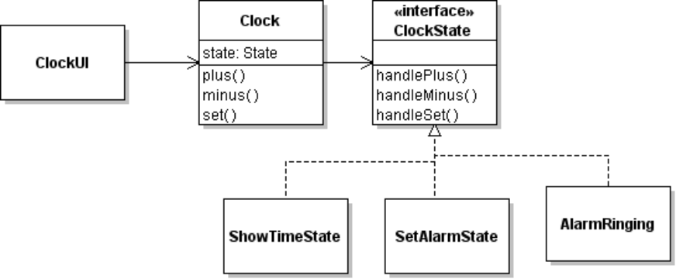

Strive for loosely coupled objects
Objects that are tightly "bound" together are difficult to change. Try to minimize the dependencies between different types of objects. The Program to an interface principle can help.

Program to an interface, not to an implementation
This means program to a specification not an implementation. "Interface" can be abstract superclass.
List Example: When our Purse uses a list or returns a list, we declare the parameter or return type to be "List" (the interface), not "ArrayList" (a List class).
Related to this principle is:

Depend on abstraction rather than concrete classes
The Purse depends only on the Valuable interface, not on the type of Valuables. In the Graphics drawing lab, the Canvas depends only on a Drawable Shape, not on a concrete type of shape like Ball.

Only talk to your friends
Avoid traversing chains of object references, such as this common way of using JDBC:
ResultSet rs = DriverConnection.getConnection(url).createStatement()
.executeQuery("SELECT * FROM USERS");
Long chains mean more dependencies and more opportunities for failure. This example uses classes in java.sql are very stable, so depending on these object is not too bad. It may still throw an exception, though.

Information Expert
When you need to decide which class to assign a responsibility to, assign it to the class that has the most information needed to fulfill the responsibility.
Example: In a sales application, which class should compute the total price of a sale?
Since the sale knows all the items in the sale, and each item knows its own price, the Sale should compute the total price.

Command/query separation
Command methods ("do something") and query methods ("ask something") should be independent. A query should not change the state of an object.

Favor composition over inheritance
(Here, "composition" means an association.)
Example: we could design the Coin Purse to extend the ArrayList class. But it is more flexible (and better encapsulation) to design Purse to encapsulate a list of Coins. The Purse has an attribute that references an ArrayList of coins.
We get 3 benefits from this:
(a) we restrict access to the list of coins since it is encapsulated inside the Purse. If Purse extended ArrayList, the user could directly access the coins.
(b) The Purse can extend some other class if we choose (like Observable).
(c) We can change the implementation to something other than ArrayList without any change to the public interface of Purse.

Implementation Guidelines
1. Code should be easy to read.
Easy to read is more important than easy to write. Use meaningful variable names, follow a coding standard, and comment your code as if you were explaining it to someone else. It is important to document the intent of your code. The reader can usually figure out "what" the code is doing by reading it, but not why.
2. Don't repeat yourself (DRY).
Avoid duplicating the same logic. Use refactoring to create a private method for repeated computations. Reuse your own code when possible.
For example, in the Purse insert() method, don't write:
if ( list.size( ) >= capacity ) return false;
Instead reuse your own logic for isFull:
if ( isFull() ) return false;

Principles for Class Interface Design
The book Object-Oriented Design and Patterns by Cay Horstmann has 5 principles for class interface design, the "5 C's" for interface design (see Chapter 3). Don't confuse these with the principles of class design listed above.
Cohesion | All methods should be related to a single responsibility or purpose. Horstmann defines cohesion in terms of "methods related to a single abstraction".
Completeness | The class should have enough methods to completely perform its responsibilities.  Example: a List has enough methods to let us insert, remove, or look at any element of the list. It also has a size() method so we know how many elements are in the list..
Clarity | The method names should be easy to understand.  Example: the List method names clearly describe what they do. isEmpty() is much clearer than empty() which could imply a command to "empty" the list.
Consistency | Names should be used consistently. The List has an isEmpty() method, but the same behavior for a Stack is named empty(). That's not consistent.
Convenience | The interface should be convenient for the programmer to use. The Collections have a clear() method that removes all elements. This isn't necessary but makes the collection easier to use. Similarly, instead of  if ( list.isEmpty() ) ...  we could use:  if ( list.size() == 0 ) ...  but isEmpty() is more convenient and easier to understand.

References
Robert Martin, "The Principles of OOD". Article describes the five SOLID principles. http://butunclebob.com/ArticleS.UncleBob.PrinciplesOfOod. This article has hyperlinks to articles describing each of the 5 SOLID principles.
ObjectMentor.com (web site). Web site of Robert Martin has several articles and book chapters available for download. http://www.objectmentor.com.
Freeman, et al. Head First Design Patterns. O'Reilly (2004). Introduces these principles (sometimes with different names) using entertaining examples.

Some Famous Books with Design and Coding Principles
Gamma, et al. Design Patterns: Elements of Reusable Object-Oriented Software. (1994) Original design patterns book introduces many of these principles.
Hunt and Thomas, The Pragmatic Programmer (1999). Books contains advice for professional development, important skills, design and code advice. Written as short sections you can read in any order.

